


Korea Lunar Exploration Program
DTNPL
Interface Control Document
Date: 04 May. 2020 | Doc. No: KPLO-SP-550-002  Issue: F.01  Total page: 30

Superseding Revised

Prepared By:  Kyung-Rak Lee Date  DTN Payload Engineer, ETRI |  | Jin-Ho Jo Date  DTN System Engineer, ETRI
Reviewed By:  Sin-Ae Ji Date  Proximity-1 System Engineer, ETRI |  | Eunhyeuk Kim Date  RLE, KPLO Payload I/F Management, KARI
Seung-Young Min Date  Engineer, KPLO Mechanical System, KARI |  | Changkyoon Kim Date  RDE, KPLO Data Handling Unit, KARI
Approval Signature:  Cheol-Oh Jeong Date  DTN Product Assurance, ETRI |  | Byoung-Sun Lee Date  DTN Project Leader, ETRI
Guen-Young Park Date  RLE KPLO Product Assurance, KARI |  | Dae-Kwan Kim Date  Head, KPLO SE&I, KARI
Yee-Jin Cheon Date  Director, Satellite Tech. Research Development Division, KARI |  | Sang-Ryool Lee Date  Director, Lunar Exploration Program Office, KARI

Original CDMO Release__________________

Revision History
Version | Author(s) |  | Date | Description
0.1 | Jin-Ho Jo |  | 2016. 12. 30 | Draft
0.2 | Jin-Ho Jo |  | 2017. 04. 12 | Update KARI review comments  Update TM/TC packet structure
1.0 | Kyung-Rak Lee |  | 2017. 10. 25 | Update PDHU interface
1.1 | Kyung-Rak Lee |  | 2017. 11. 02 | Add power connector information  Update Table 3-5  Add comm. connector information  PDHU data packet structure was updated  Add mechanical interface section  Add thermal interface section
1.2 | Kyung-Rak Lee |  | 2018. 01. 10 | Update KARI review comments
1.3 | Jin-Ho Jo |  | 2018. 09. 13 | Add PDHU interface timing diagram
1.4 | Kyung-Rak Lee |  | 2018. 10. 26 | Update TM/TC header format  Update SOH structure  Update the role of MOC
1.5 | Jin-Ho Jo |  | 2019. 03. 13 | Change UART ACK mode  Update TM list
1.6 | Dae Soo Oh |  | 2019. 04. 18 | Mechanical interface was updated  Thermal interface was updated
1.7 | Jin-Ho Jo |  | 2019. 04. 25 | Update SOH TM
1.8 | Kyung-Rak Lee |  | 2019. 06. 05 | Update TM/TC list (cyan colored)
F.00 | Jin-Ho Jo |  | 2020. 01. 20 | Issue version F.00
F.01 | Jin-Ho Jo |  | 2020. 05. 04 | Update ACK definition  Add appendix

Revision/Change Records
Version | Date | Revision/Change Description | Pages
0.1 | 2016. 12. 30 | Initial | All
0.2 | 2017. 04. 12 | Update Applicable Documents  Update Figure 2-1  Update Table 3-1 (red color)  Add TBD to the Table 3-5 title  Update Table 3-1 (red color)  Update Figure 4-1  Update Table 4-2 (red color)  Update Table 4-4 (red color) | 8  11  13  15  15  17  18  18
1.0 | 2017. 10. 25 | Add abbreviations to Section 1.3  Update Figure 3-1  Update Figure 3-2  Update Table 3-1  Update Table 3-6  Update Table 4-4  Update Figure 4-2  Update Table 4-5  Update Table 4-6  Update Table 4-7  Update Table 4-8  Update Table 4-9  Update Table 4-10 | 8, 9  12  12  13  16  18  19  19  19  20  20  20  21
1.1 | 2017. 11. 03 | Add power connector information  Update Table 3-5  Add comm. connector information  PDHU data packet structure was updated  Mechanical interface added  Thermal interface added | 14  16  16  20  23  25
1.2 | 2018. 01. 10 | Change document title  Change section title from [other document] to [KARI document]  Add operation duty | All  8  13
1.3 | 2018. 09. 13 | Add PDHU interface timing diagram | 21
1.4 | 2018. 10. 26 | Update the role of MOC in Chapter 2.3  Update Figure 4-1  Update Table 4-2  Update Table 4-3  Update Table 4-5  Update Table 4-8  Update Table 4-9
1.5 | 2019. 03. 13 | Change UART interface ACK mode from [echo beck] to [OK check]  Update Table 4-3  Update Table 4-9 | 19  20  24
1.6 | 2019. 04. 18 | Mechanical interface was updated  Thermal interface was updated | 26-29  30
1.7 | 2019. 04. 25 | ACK method update (echo back to OK check)  Update Table 4-3 | 21  22
1.8 | 2019. 06. 05 | Update chapter 4.1.2  Update chapter 4.1.3 | 21  22
F.00 | 2020. 01. 20 | Delete [TBC]  Delete <echo request> TC  Delete <SW initialize> TC  Delete <echo reply> TM  Delete RFU in TC/TM | 15, 19  21, 24  21, 24  21, 25  21, 24
F.01 | 2020. 05. 20 | Define ACK packet in the UART protocol  Delete ACK, NACK in the TM list  Update script1 command  Delete ACK, NACK in the TM list  Add Appendix | 20  21  21  24  30

Documents Tree

Contents

1. Introduction 10
1.1. Purpose and Scope 10
1.2. Applicable Documents 10
1.2.1. ETRI Documents 10
1.2.2. KARI Documents 10
1.3. Abbreviations 10
2. Overview of KPLO DTN 12
2.1. DTN and Space Communications 12
2.2. Mission of DTN Operation 12
2.3. DTN Configurations 12
2.4. Communication Nodes 13
2.4.1. DTN nodes 13
2.4.2. Non-DTN nodes 13
3. Electrical Interface 14
3.1. Power Interface 15
3.2. TM/TC (DMA UART, Bi-level) Interface 16
3.3. Data Downlink Interface 18
4. Communication Protocols 20
4.1. TM/TC Protocols 20
4.1.1. UART Protocol 20
4.1.2. Packet Format 20
4.1.3. TM/TC Data Structure4 21
4.2. Datalink Protocol 21
4.2.1. Datalink protocol for downlink 21
4.2.2. Datalink Data Structure 22
4.2.3. Interface Timing Diagram 23
4.3. TM/TC Lists 23
4.3.1. Command Lists 23
4.3.2. Telemetry Lists 24
5. Mechanical Interface 25
5.1. Mechanical Configuration 25
5.2. Spacecraft Interface 26
5.3. Mass Budget 26
5.4. Mass Properties 27
5.4.1. Center of gravity 27
5.4.2. Moment of inertia 28
6. Thermal Interface 29
6.1. Thermal Contact Area 29
6.2. Thermal Characteristic 29
7. Appendix 30

Figures

Figure 2.1 DTN test configuration in the first phase 13
Figure 3-1 Interface diagram of DTN payload 14
Figure 3-2 Electrical block diagram of DTN payload 14
Figure 3-3 Power scheme of DTNPL 15
Figure 3-4 DTNPL DC power connector location 16
Figure 3-5 Interface diagram for UART TM/TC 17
Figure 3-6 Interface diagram for bi-level TM/TC 18
Figure 3-7 DTNPL interface connector location 18
Figure 3-8 Interface diagram for data downlink 19
Figure 4-1 TM/TC packet structure 20
Figure 4-2 Downlink datalink packet structure 22
Figure 4-3 Datalink interface timing diagram 23
Figure 5-1 DTNPL Mechanical Configuration 26
Figure 5-2 DTNPL Exploded Configuration 26
Figure 5-3 Center of gravity 28
Figure 6-1 Thermal Contact Area 30

Tables

Table 3-1 Electrical interface summary of DTNPL 15
Table 3-2 Power connector (J01) pin assignment of DTNPL 16
Table 3-3 UART TM/TC Interface of DTNPL 16
Table 3-4 Bi-level TM/TC interface of DTNPL 17
Table 3-5 TM/TC (DMA UART, bi-level) interface connector(J02) pin assignment 18
Table 3-6 Data downlink interface of DTNPL 18
Table 4-1 DTNPL Protocols 20
Table 4-2 TM/TC Packet Format 20
Table 4-3 TM/TC data structure 21
Table 4-4 Datalink packet structure 22
Table 4-5 Contents of User Data Field 22
Table 4-6 First frame datalink structure 23
Table 4-7 Last frame datalink structure 23
Table 4-8 DTNPL Command Lists 24
Table 4-9 DTNPL Telemetry Lists 24
Table 5-1 Mass Budjet 27
Table 5-2 Center of gravity 28
Table 5-3 Moment of inertia 29

Introduction

Purpose and Scope
This document defines the electrical and mechanical interfaces between KPLO bus and DTN payload.

Applicable Documents

ETRI Documents
Document Number | Document Title
KPLO-D0-550-000 | System Requirement of DTN Payload
KPLO-SP-550-001 | System Specification of DTN Payload

KARI Documents
Document Number | Document Title
KPLO-SP-310-001 | KPLO System Specification Document
KPLO-D0-500-001 | KPLO Payload Interface Requirements
 | DMAUART Interface Requirement for Command and Telemetry Operation of Payload (Appendix)

Abbreviations
AMS | Asynchronous Message Service
BP | Bundle Protocol
BSS | Bundle Streaming Service
CCSDS | Consultative Committee for Space Data Systems
CFDP | CCSDS File Delivery Protocol
CRC | Cyclical Redundancy Check
DCC | DTN Control Center
DMA | Direct Memory Access
DSA | DTN Service Adaptor
DTN | Delay(Disruption) Tolerant Network
DTNPL | DTN Payload
EOD | End of Data
EOF | End of File
FW | Firm Ware
FSW | Flight Software
ION | Interplanetary Overlay Network
KDSA | Korea Deep Space Antenna
KPLO | Korea Pathfinder Lunar Orbiter
LCM | Lander Communication Model
LTP | Licklider Transmission Protocol
MOC | Mission Operation Center
OBC | On Board Computer
OBT | On Board Time
PDHU | Payload Data Handling Unit
RCM | Rover Communication Model
RFU | Reserved for Future Use
SBC | Single Board Computer
SBMU | Spacecraft Bus Management Unit
SOD | Start of Data
SOF | Start of File
SOH | Start of Head
TBC | To Be Confirmed
TBD | To Be Defined
TC | Tele-command
TCP | Transmission Control Protocol
TM | Telemetry
UART | Universal Asynchronous Receiver Transmitter
USRT | Universal Synchronous Receiver Transmitter

Overview of KPLO DTN

DTN and Space Communications
Delay/disruption tolerant networking (DTN) technology offers a new solution to highly stressed communications in space environments, especially those with long link delay and frequent link disruptions in deep space missions. Delay/disruption tolerant networking (DTN) technology offers a new solution that use a store-and-forward mechanism to combat long link delay and frequent link disruptions generally characterizing space communications. DTN communications use a bundle protocol (BP), to construct a store-and-forward overlay network. The BP, situated at the application layer of the Internet model, utilizes conventional Internet protocols to send and receive data bundles. The benefits of DTN communications are as follows.
- Interoperability and Reuse: A standardized DTN protocol suite enables interoperability of multi-agency communication assets and also allows NASA to use the same communication stack for future missions (LEO, NEO or Deep Space).
- Space Link Efficiency, Utilization and Robustness: DTN enables more reliable and efficient data transmissions resulting in more usable bandwidth. DTN also improves link reliability by having multiple network paths and assets for potential communication hops.
- Security: The DTN Bundle Security Protocol (BSP) allows for integrity checks, authentication and encryption, even on links where not previously used.
- Quality of Service: The DTN protocol suite allows for many priority levels to be set for different data types, ensuring that the most important data is received ahead of less important data.
- Improved Operations and Situational Awareness: The DTN store-and-forward mechanism along with automatic retransmission provides more insight into events during communication outages and significantly reduces the need for ground-based scheduling.

Mission of DTN Operation
The mission of DTN is to validate DTN communication protocols by space link testing through KPLO. So DTN operations are focused on testing the DTN protocols using KPLO space links.

DTN Configurations
In the first phase of lunar exploration, test lunar orbiter called Korea Pathfinder Lunar Orbiter (KPLO) will be launched without lunar lander. Figure 2.1 shows DTN configuration in first phase of lunar exploration. There are no Lander and Rover on the moon in first phase. So Lander Communication Model (LCM) and Rover Communication Model (RCM) will be located on earth for the DTN communication testing.
DTN Payload (DTNPL) is a DTN node in the space. DTNPL will be mounted on the KPLO for DTN communication. DTN Control Center (DCC) is a control center of DTN communication nodes. Lander Communication Model (LCM), Rover Communication Model (RCM), and Mission Operation Center (MOC) are DTN nodes on ground. All DTN nodes on ground are interconnected by the terrestrial network such as Internet. However, Korea Deep Space Antenna (KDSA) is not DTN node. It just transfers DTN packets to next communication nodes.

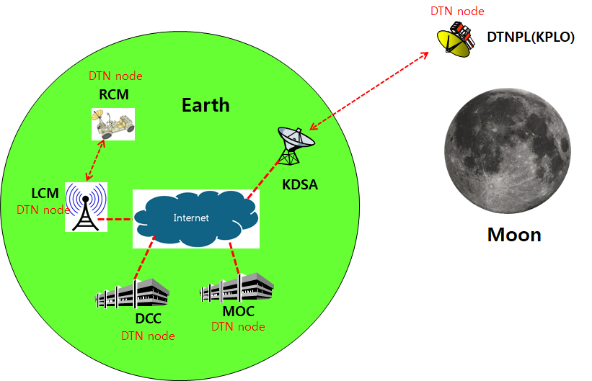
Figure 2.1 DTN test configuration in the first phase

Communication Nodes
Many communication nodes are needed for the DTN operation. Some of communication nodes in the network are DTN nodes whereas otherwise nodes are non-DTN nodes. The function of communication nodes used in the DTN operation is as follows.

DTN nodes
- DCC is a ground DTN node which monitor and controls DTN nodes. DCC send commands to DTN nodes such as DTNPL, LCM and RCM. It also receives telemetries or acquired data from some DTN nodes such as RCM or LCM.
- DTNPL is a DTN node mounted on the KPLO. DTNPL can be operated as a DTN end point. And it also can be operated as relay nodes which relay DTN data between DCC and RCM or LCM.
- LCM is a ground DTN node. LCM relays DTN data between MOC and RCM.
- RCM is a ground DTN node and a DTN end point. The commands sent by the DCC is terminated at the RCM and the RCM returns telemetry or data to DCC through KPLO.
- MOC is a ground DTN node which monitors and controls KPLO and payloads. MOC also receives and processes data generated from the payloads and transfers to each payload control center.

Non-DTN nodes
- KDSA is a ground station for deep space communication. KDSA will have a big size of antenna and RF equipment for space link interface. KDSA also has network equipment for terrestrial communication interface such as SLE link. KDSA is a non-DTN node.

Electrical Interface
The DTN payload (DTNPL) shall have interface with KPLO for the operational power supply and for the communications. The following figure shows DTN payload interface diagram with KPLO.

Figure 3-1 Interface diagram of DTN payload

There are four kinds of interface types between DTNPL and KPLO. Each interface types are described as following.
- TM/TC (bi-level): One bi-level TC and one bi-level TM for DTNPL emergency operation.
- Bi-level TC: System reset command in the emergence condition
- Bi-level TM: Telemetry showing that DTNPL is in alive
- TM/TC (UART): Serial communication channel for TM/TC communication with KPLO SBMU
- Data downlink (USRT): Serial data downlink channel to KPLO PDHU
- Power: Operation DC power +28V from the KPLO PCDU

The detailed electrical configuration of DTNPL is shown below figure.

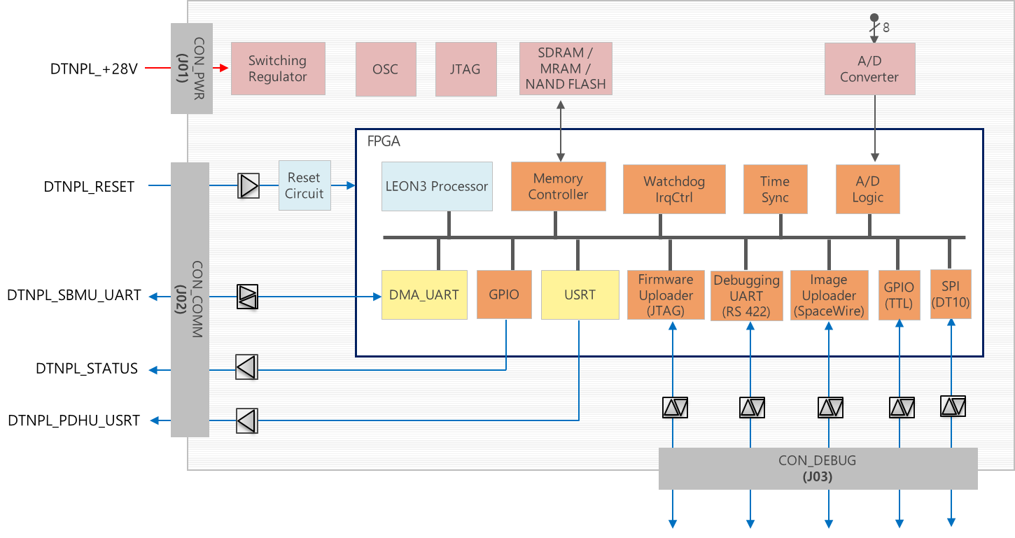
Figure 3-2 Electrical block diagram of DTN payload

The following table shows characteristics of electrical interface of DTNPL.
Table 3-1 Electrical interface summary of DTNPL
 | Type | Mnemonic | Physical I/F | Direction | Description | Connector
Power | +28V | DTNPL_+28V | Nominal +28V (24~32.8)Vdc | Bus(PCDU) DTNPL(SBC) | DTN Power | CON_PWR
TM/TC  (TLM / CMD) | Bi-level TM | DTNPL_STATUS | Bi-level TM  - Logic LOW : 0V  - Logic HIGH : 5V | Bus(SBMU) DTNPL(SBC) | 0.25 Hz  Heartbeat | CON_COMM
TM/TC  (TLM / CMD) | Bi-level TC | DTNPL_RESET | Bi-level TC  - Logic LOW : 0V  - Logic HIGH : 5V | Bus(SBMU) DTNPL(SBC) | DTN Run (0V, Default)  DTN Reset (5V)  Duration>1msec. | CON_COMM
TM/TC  (SBMU) | DMA_UART | DTNPL_SBMU_UART | RS422 Differential | Bus(SBMU) DTNPL(SBC) | 115.2 kbps | CON_COMM
TM/Data downlink  (PDHU) | USRT | DTNPL_PDHU_UART | RS422 Differential | Bus(PDHU) DTNPL(SBC) | 2.0 Mbps | CON_COMM

Power Interface
The DTNPL has the DC power interface to get operation power from the KPLO (+28 V). Secondary power values of DTNPL are +5V, +3.3V and +1.2V..
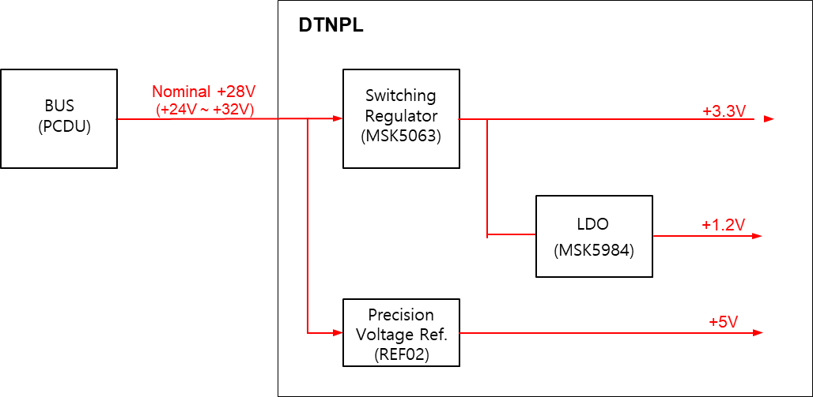
Figure 3-3 Power scheme of DTNPL

- Power consumption: The maximum power consumption of DTNPL does not exceed 12 W.
- Operation duty: DTNPL will be operated in orbit irregularly. So, it is difficult to define operation duty. For example, DTNPL can be operated as following;
- SOM + 2 weeks: DTNPL operation time is 40 minutes twice per day
- Until MOM, DTNPL will be non-operated
- MOM + 2 weeks: DTNPL operation time is 40 minutes twice per day
- Until EOM, DTNPL will be non-operated
- EOM + 2 weeks: DTNPL operation time is 40 minutes twice per day
- SOM: Start of Mission
- MOM: Middle of Mission
- EOM: End of Mission

Table 3-2 Power connector (J01) pin assignment of DTNPL
Pin | Description | Pin | Description | Pin | Description
1 | DTNPL_+28V | 6 | (Reserved) | 11 | DTNPL_+28V_rtn
2 | DTNPL_+28V | 7 | (Reserved) | 12 | DTNPL_+28V_rtn
3 |  | 8 | (Reserved) | 13
4 |  | 9 | (Reserved) | 14
5 |  | 10 | (Reserved) | 15

Detailed Connector Information is as follow.
- Part Type : HD15 Male
- Part Number : 280-018P1H15Z2GP
- Vendor : Glenair

The DC power connector location is shown below.

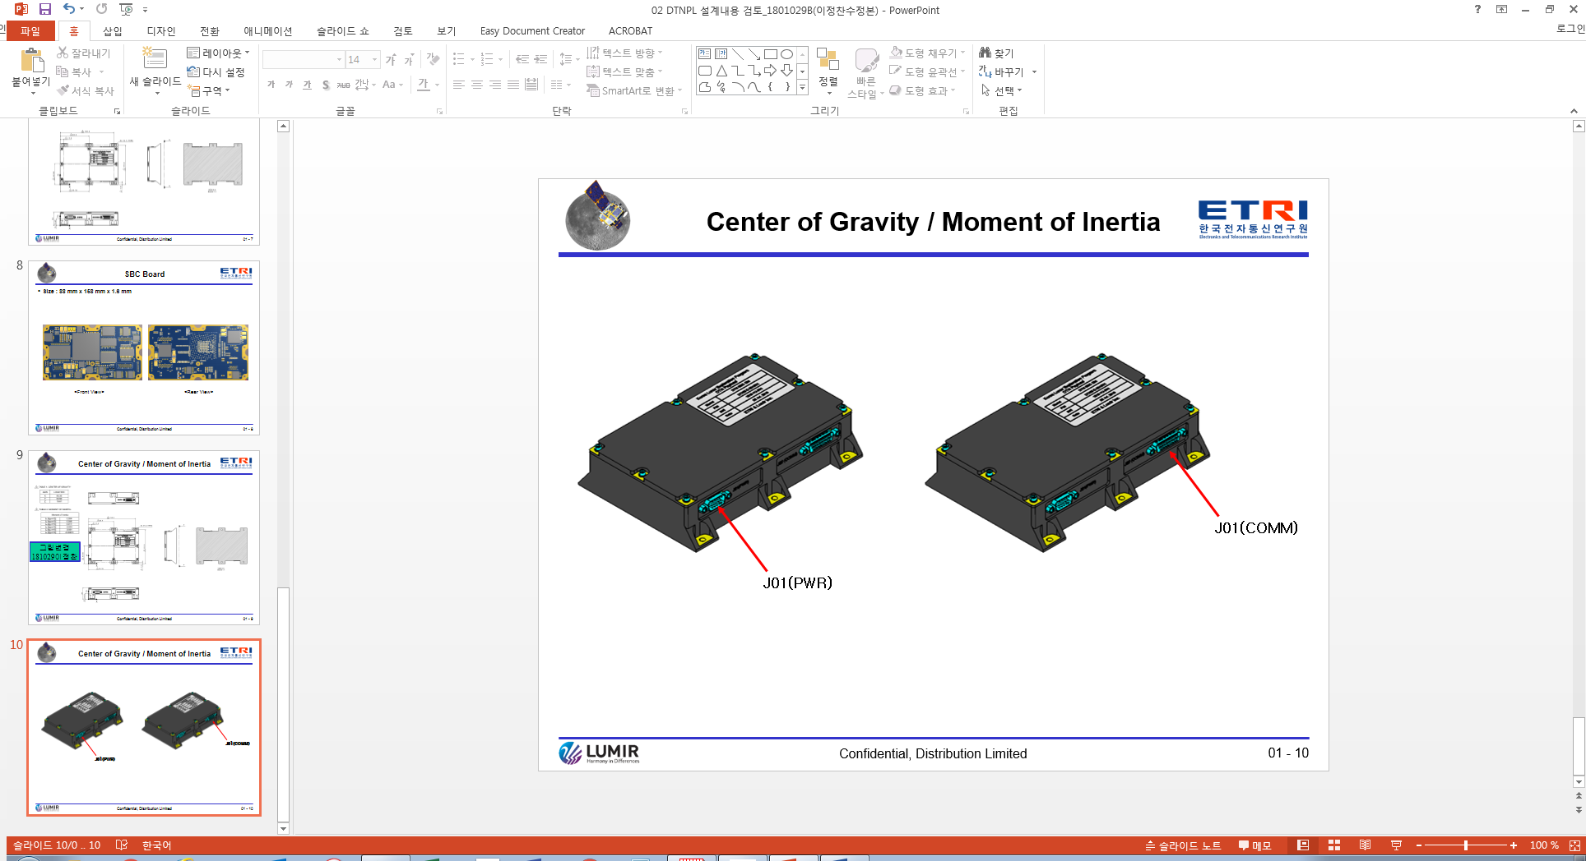
Figure 3-4 DTNPL DC power connector location

TM/TC (DMA UART, Bi-level) Interface
TM/TC (DMA UART) Interface is as below.

Table 3-3 UART TM/TC Interface of DTNPL
Type | DMA_UART
Mnemonic | DTNPL_SBMU_UART
Physical I/F | RS422 Differential
Direction | Bus(SBMU) DTNPL(SBC)
Description | 115.2 kbps

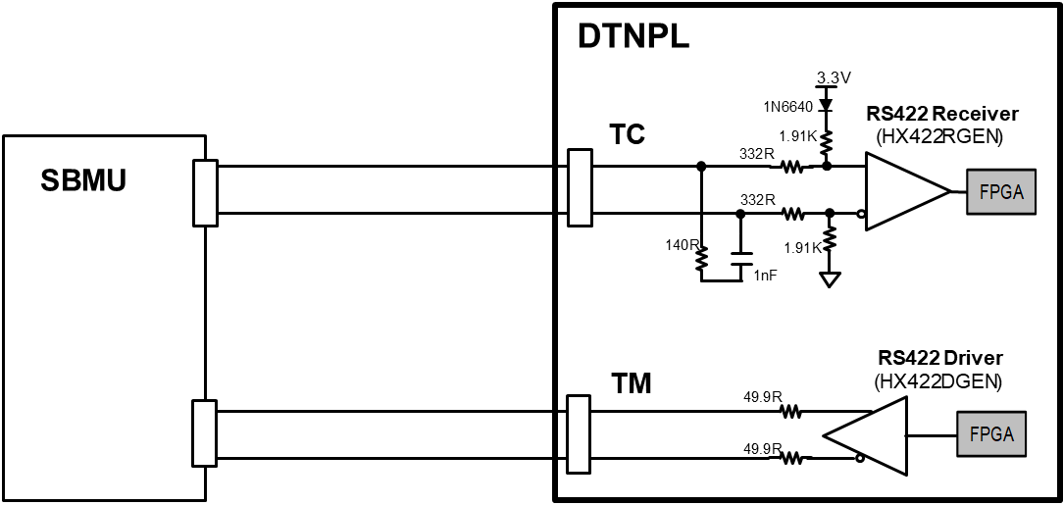
Figure 3-5 Interface diagram for UART TM/TC

TM/TC (bi-level) Interface is as below.

Table 3-4 Bi-level TM/TC interface of DTNPL
Type | Bi-level TM | Bi-level TC
Mnemonic | DTNPL_STATUS | DTNPL_RESET
Physical I/F | Logic LOW: 0V  Logic HIGH: 5V | Logic LOW: 0V  Logic HIGH: 5V
Direction | Bus(SBMU) DTNPL(SBC) | Bus(SBMU) DTNPL(SBC)
Description | 0.25 Hz (Duty 50:50)  Heartbeat | DTN Run (0V, Default)  DTN Reset (5V)

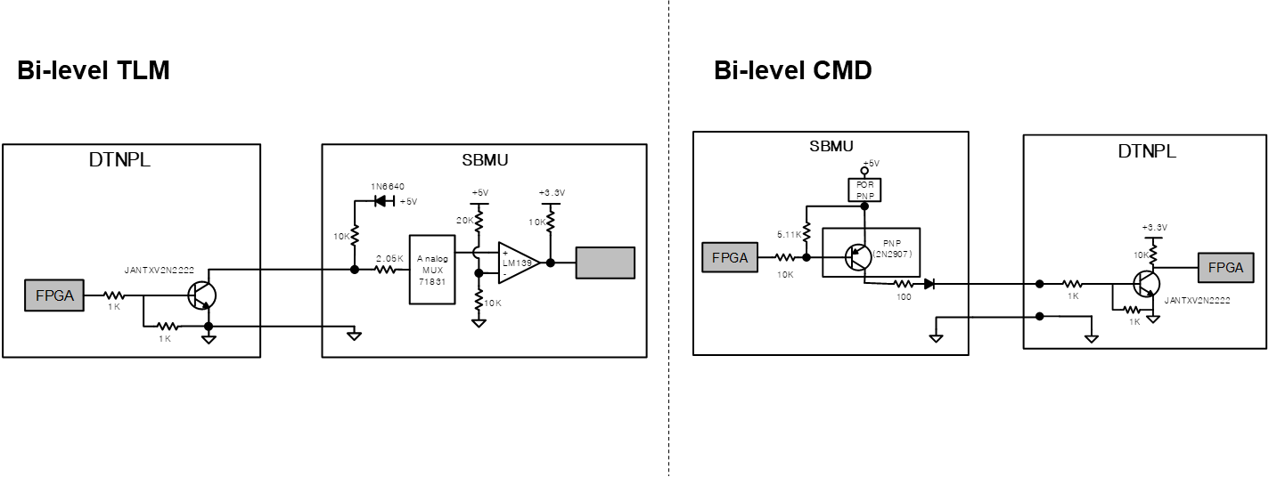
Figure 3-6 Interface diagram for bi-level TM/TC

TM/TC (DMA UART, bi-level) Interface Connector Pin map is as below.

Table 3-5 TM/TC (DMA UART, bi-level) interface connector(J02) pin assignment
Pin | Description | Pin | Description | Pin | Description
1 | DTNPL_UART_SBMU_Tx_DTNPL_Rx_P | 10 | DTNPL_PDHUp_Rx_DTNPL_TxEn_P | 19 | (Reserved)
2 | DTNPL_UART_SBMU_Tx_DTNPL_Rx_N | 11 | DTNPL_PDHUp_Rx_DTNPL_TxEn_N | 20 | (Reserved)
3 | DTNPL_UART_SBMU_Rx_DTNPL_Tx_P | 12 | (Reserved) | 21 | (Reserved)
4 | DTNPL_UART_SBMU_Rx_DTNPL_Tx_N | 13 | DTNPL_PDHUr_Rx_DTNPL_TxData_P | 22 | (Reserved)
5 | (Reserved) | 14 | DTNPL_PDHUr_Rx_DTNPL_TxData_N | 23 | DTNPL_STATUS
6 | DTNPL_PDHUp_Rx_DTNPL_TxData_P | 15 | DTNPL_PDHUr_Rx_DTNPL_TxClk_P | 24 | DTNPL_STATUS_rtn
7 | DTNPL_PDHUp_Rx_DTNPL_TxData_N | 16 | DTNPL_PDHUr_Rx_DTNPL_TxClk_N | 25 | DTNPL_RESET
8 | DTNPL_PDHUp_Rx_DTNPL_TxClk_P | 17 | DTNPL_PDHUr_Rx_DTNPL_TxEn_P | 26 | DTNPL_RESET_rtn
9 | DTNPL_PDHUp_Rx_DTNPL_TxClk_N | 18 | DTNPL_PDHUr_Rx_DTNPL_TxEn_N

Detailed Connector Information is as follow.
- Part Type : HD26 Female
- Part Number : 280-019S2H26Z2GP
- Vendor : Glenair

Figure 3-7 DTNPL interface connector location

Data Downlink Interface
Data Downlink Interface with PDHU is as below.

Table 3-6 Data downlink interface of DTNPL
Type | USRT
Mnemonic | DTNPL_PDHU_USRT
Physical I/F | RS422 Differential
Direction | Bus(PDHU) DTNPL(SBC)
Description | 2.0 Mbps

Figure 3-8 Interface diagram for data downlink

Communication Protocols
There are two kinds of communication protocols between DTNPL and KPLO as following.

Table 4-1 DTNPL Protocols
 | TM/TC Protocol | Datalink Protocol
Communication link | DTNPL ↔ SBMU(KPLO) | DTNPL → PDHU(KPLO)
Application | TM/TC communication (SBMU ↔ DTNPL)  File transfer using DTN (SBMU → DTNPL) | File transfer using DTN (DTNPL → PDHU)  Video streaming using DTN (DTNPL → PDHU)
ACK | OK check | None
Single/Multiple | Single packet: TM/TC  Multiple packets: File transfer | Multiple packets

TM/TC Protocols

UART Protocol
DMA UART will be used for the communication between DTNPL and KPLO SBMU.
- Baud rate: 115.2 kbps
- None-Parity, 8 Data bit and 1 Start/Stop bit (N, 8, 1)
- ACK method: OK check
  - ACK: 0x12 (1 byte)
  - ACK response time: within 100us
- ID pattern: 0xAA
Time interval between the commands are 125ms as a minimum.
So, DTNPL have to handle sequential commands at 125ms interval.

Packet Format
The maximum packet size is 70 byte. The TM/TC packet is consists of following fields.

Figure 4-1 TM/TC packet structure

The packet fields are defined in following table.

Table 4-2 TM/TC Packet Format
Field name | Size | Description | Value
Sync | 1 byte | Sync pattern for UART communication | 0xAA
Length | 2 byte | Length of data field (byte) | 0 (0x0000) ~ 65 (0x0041)
Command | 1 byte | Transmit Channel (1 bit) | SBC (0), DTN (1)
Command | 1 byte | Response Channel (1 bit) | SBMU (0), PDHU (1)
Command | 1 byte | Type (2 bits) | SBC TC (00 b), SBC TM (01 b)
Command | 1 byte | Command number (4 bits) | 0 (0000 b) ~ 15 (1111 b)
Pkt no | 1 byte | Sequence number of DTN Segment  (only used in DTN data traffic, not in TC/TM) | 0 (0x00) ~ 255 (0xFF) in DTN
Pkt no | 1 byte |  | 0 (0x00) in TC/TM
Data | Variable  (max. 65 byte) | - DTN data from DCC to DTNPL  - TC from MOC to DTNPL  - TM from DTNPL to SBMU/MOC

TM/TC Data Structure4
TM/TC data structure is as following.

Table 4-3 TM/TC data structure
Type | Name | Sync | Length | Command | Packet No | Payload Data | Corresponding Action
TC | Time setting |  | 0x0006 | 0x02 | 0x00 | OBT  - week since 2000-01-01 12:00:00 UTC (2 byte)  - octant second (4 byte) | ACK or NACK
TC | SOH request |  | 0x0000 | 0x03 | 0x00 | None | SOH data or NACK
TC | Script1  (ionstart, killm) |  | Variable (max.)  - ionstart : 0x000E  - killm : 0x0009 | 0x04 | 0x00 | Script command  - ionstart: max. 14 byte  - killm: max. 9 byte | ACK or NACK
TC | Script2  (DCC data) |  | Variable  - 0x0000~0x0041 | 0xC6 | 0x00 ~ 0xFF | DCC TC/data (0 ~ 65 byte) | ACK or NACK
SBC TM | SOH data | 0xAA | 0x41 | 0x14 | 0x00 | SOH data (65 byte)
SBC TM | NACK | 0xAA | 0x41 | 0x15 | 0x00 | Reserved (65 byte) | Delete
SBC TM | ACK | 0xAA | 0x41 | 0x16 | 0x00 | Reserved (65 byte) | Delete

Datalink Protocol
Datalink protocol is used for payload data transfer from DTNPL to PDHU. USRT will be used for the datalink protocol and characteristics are as following.

Datalink protocol for downlink
The downlink datalink packet structure can be expressed logically as following.
- Packet structure = VN + Type + SHF + APID + SF + PSC + PL + SP + User data + CRC
  - Where; VN: Version Number, SHF: Secondary Header Flag, APID: Application Process ID, SF: Sequence Flags, PSC: Packet Sequence Count, PL: Packet Length, SP: Sync Pattern, CRC: Cyclic Redundancy Check
The downlink datalink packet structure can be expressed as following figure.

Figure 4-2 Downlink datalink packet structure

The datalink packet structure is as following.
Table 4-4 Datalink packet structure
Field name | Size (bit) | Description | Comments
VN | 3 | 000b | Version 1
Type | 1 | 0b | Telemetry
SHF | 1 | 1b
APID | 11 | 11 bits  APID is determined by the destination EID of DTN segment received from DTNPL-ION
SF | 2 | 11b (standalone) or combination of 01b / 00b / 10b (first / continue / last)
PSC | 14 | Modulo-16384, 0 ~ 16383 | The sequential binary count of each packet
PL | 16 | (Length of SP)+(Length of User Data Field)+(Length of CRC) -1
SP | 32 | 0x352EF853
User Data Field | Variable | Max 65536 Octets. Refer to Table 4-5.
CRC | 16 | CRC-16-CCITT (Polynomial: x¹⁶+x¹²+x⁵+1)  Calculation field: (SP)+(User Data Filed)

The contents of User Data Field are as following.
Table 4-5 Contents of User Data Field
Sub-field | Size (byte) | Description | Comments
Sync | 1 | Sync pattern for USRT communication
Length | 2 | Length of Data field in User Data Field (byte)
Command | 1 | Same to command field of TM/TC packet. Refer to Table 4-2
Packet No. | 1 | Same to Pkt no field of TM/TC packet. Refer to Table 4-2
Data | Variable (Max. 2043) | Variable.  Max. 2043 Octets. | - message  - File data  - Streaming data

Datalink Data Structure
Datalink data structure is as following.
Table 4-6 First frame datalink structure
VN | Type | SHF | APID | SF | PSC | PL | SP | User Data Field | CRC
000b | 0b | 1b | xxx xxxx xxxxb | 01b | 00 0000 0000 0000b | xxxx xxxx …. | 0x352EF853 | Variable

Table 4-7 Last frame datalink structure
VN | Type | SHF | APID | SF | PSC | PL | SP | User Data Field | CRC
000b | 0b | 1b | xxx xxxx xxxxb | 10b | xx xxxx xxxx xxxxb | xxxx xxxx …. | 0x352EF853 | Variable

Interface Timing Diagram
The interface timing diagram for datalink is as following.

Figure 4-3 Datalink interface timing diagram

Clock-synchronized data should be transferred during the enable signal is in high state.
CLK signal should be continue 16 cycles after enable signal is low state for the PDHU post processing.
Fill pattern should be transferred, when data is absent.
Data would be sampled at clock rising-edge.

TM/TC Lists

Command Lists
There are two kinds of command types in the DTNPL as following.
- SBC commands: DTNPL control
- DTN commands: ION-DTN control. They are transmitted by AMS from DCC to DTNPL.
The DTNPL command lists are shown in following table.

Table 4-8 DTNPL Command Lists
Type | TC name | Description
 | Time setting | Set On Board Time
 | SOH request | Request SOH TM
 | Script (ion start) | ION Start
 | Script (killm) | Close all process
DTN | DCC data | BPM TC / CFDP file data transfer

Telemetry Lists
There are three kinds of telemetry types as following.
- SBC telemetries: The SOH (State Of Health) of DTN payload to be reported to the KPLO FSW to monitor DTNPL health condition.
- DTN telemetries: Response to DTN command. They are transmitted by BP message from DTNPL to DCC.

The detailed telemetry lists are shown in below.

Table 4-9 DTNPL Telemetry Lists
Type | TM name | Description | Size  (byte) | Start time  (sec.) | Update interval | Transmit interval to FSW
SBC | SOH Data | temp_board (Board temperature) | 4 | Auto count after DTNPL power ON | <1 sec. | 32 sec.  (FSW send SOH request TC to DTNPL at every 32 sec.)
SBC | SOH Data | temp_fpga (FPGA temperature) | 4 | Auto count after DTNPL power ON | <1 sec. | 32 sec.  (FSW send SOH request TC to DTNPL at every 32 sec.)
SBC | SOH Data | volt_28 (28.0V input voltage level) | 2 | Auto count after DTNPL power ON | <1 sec. | 32 sec.  (FSW send SOH request TC to DTNPL at every 32 sec.)
SBC | SOH Data | volt_3.3 (3.3V voltage level) | 2 | Auto count after DTNPL power ON | <1 sec. | 32 sec.  (FSW send SOH request TC to DTNPL at every 32 sec.)
SBC | SOH Data | volt_1.2 (1.2V voltage level) | 2 | Auto count after DTNPL power ON | <1 sec. | 32 sec.  (FSW send SOH request TC to DTNPL at every 32 sec.)
SBC | SOH Data | curr_28 (28.0V input current level) | 2 | Auto count after DTNPL power ON | <1 sec. | 32 sec.  (FSW send SOH request TC to DTNPL at every 32 sec.)
SBC | SOH Data | time (Current DTNPL time) | 6 | Auto count after DTNPL power ON | 1 sec. | 32 sec.  (FSW send SOH request TC to DTNPL at every 32 sec.)
SBC | SOH Data | run_time (Time(second) count after DTNPL power on) | 4 | Auto count after DTNPL power ON | 1 sec. | 32 sec.  (FSW send SOH request TC to DTNPL at every 32 sec.)
SBC | SOH Data | fpga_ver (SBC FPGA version) | 1 | Auto count after DTNPL power ON | Fixed | 32 sec.  (FSW send SOH request TC to DTNPL at every 32 sec.)
SBC | SOH Data | fw_ver (SBC firmware version) | 1 | Auto count after DTNPL power ON | Fixed | 32 sec.  (FSW send SOH request TC to DTNPL at every 32 sec.)
SBC | SOH Data | edac (EDAC count) | 4 | Auto count after DTNPL power ON | Event occurred | 32 sec.  (FSW send SOH request TC to DTNPL at every 32 sec.)
SBC | SOH Data | tmtc_rx_pkt_cnt (SBMU→DTNPL received packet count) | 4 | Auto count after DTNPL power ON | When packet received | 32 sec.  (FSW send SOH request TC to DTNPL at every 32 sec.)
SBC | SOH Data | tmtc_tx_pkt_cnt (DTNPL→SBMU send packet count) | 4 | Auto count after DTNPL power ON | When packet sent | 32 sec.  (FSW send SOH request TC to DTNPL at every 32 sec.)
SBC | SOH Data | downlink_pkt_cnt (DTNPL→PDHU send packet count) | 4 | Auto count after DTNPL power ON | When packet sent | 32 sec.  (FSW send SOH request TC to DTNPL at every 32 sec.)
SBC | SOH Data | dtn_state (ION start/stop state) | 1 | Auto count after DTNPL power ON | 1 sec. | 32 sec.  (FSW send SOH request TC to DTNPL at every 32 sec.)
SBC | SOH Data | ion_ver (ION version) | 2 | Auto count after DTNPL power ON | Fixed | 32 sec.  (FSW send SOH request TC to DTNPL at every 32 sec.)
SBC | NACK | NACK response | 0 | - | NA | Delete
SBC | ACK | ACK response | 0 | - | NA | Delete

Mechanical Interface

Mechanical Configuration
The DTNPL consisted of 1 SBC Board, 1 Housing and 1 Top Cover.
Total Mass: 0.79kg (Tolerance ±5%)
Dimension: W x L x H = 120 x 170 x 39 mm
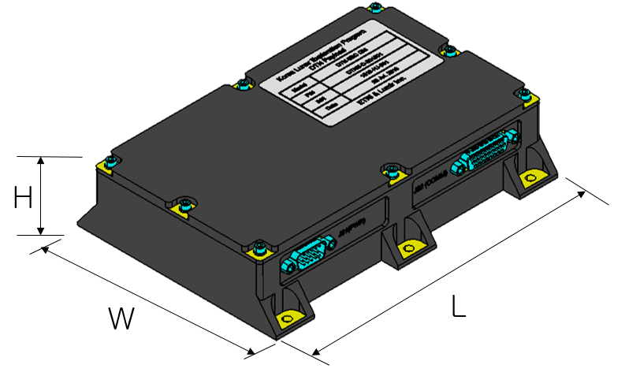
Figure 5-1 DTNPL Mechanical Configuration

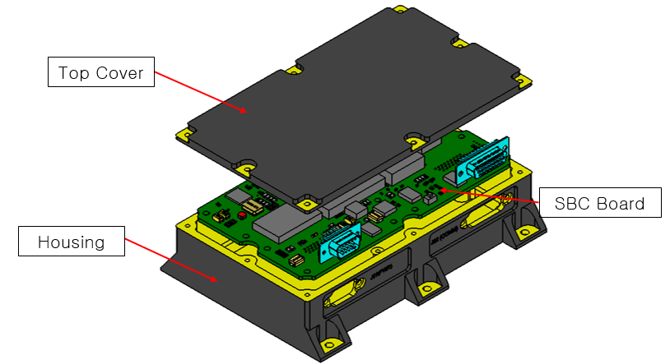
Figure 5-2 DTNPL Exploded Configuration

Spacecraft Interface
The DTNPL is fixed by six M4 bolts on Spacecraft
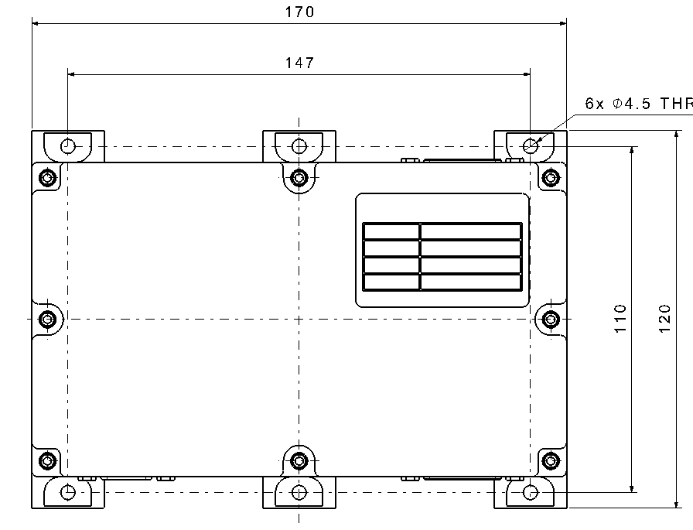

Mass Budget
Table 5-1 Mass Budjet
Name | Mass [kg] | Remark
Housing | 0.37 | Measured weight
Top Cover | 0.23 | Measured weight
SBC PCB+EEE Parts | 0.15 | Measured weight
etc (bolts…) | 0.04
Total Sum | 0.79 | Tolerance ±5%

Mass Properties

Center of gravity
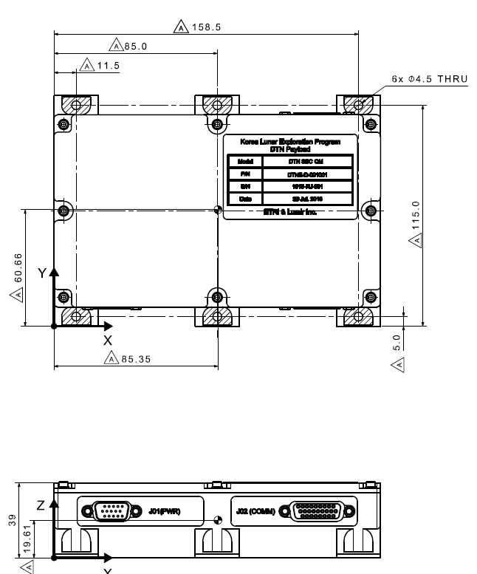

Figure 5-3 Center of gravity

Table 5-2 Center of gravity
Axis | Location
X | 85.35
Y | 60.66
Z | 19.61

Moment of inertia
Table 5-3 Moment of inertia
Moment of inertia
I_{xx} [ ${kg-m}^{2}$ ] | 0.004
I_{yy} [ ${kg-m}^{2}$ ] | 0.008
I_{zz} [ ${kg-m}^{2}$ ] | 0.011
I_{xy} [ ${kg-m}^{2}$ ] | -0.004
I_{yz} [ ${kg-m}^{2}$ ] | -0.001
I_{xz} [ ${kg-m}^{2}$ ] | -0.00874

Thermal Interface
The DTNPL monitor temperature of FPGA (Hot point) and PCB (Cold point) using its temperature sensing circuit.
No thermistors are required from the spacecraft side for the temperature monitor.
No thermal fillers are required between the bottom side of DTNPL and spacecraft panel during the equipment mounting.

Thermal Contact Area
The area of the thermal contact surface of DTN PL is 0.018$m^{2}$, and the shape is shown in the figure below.
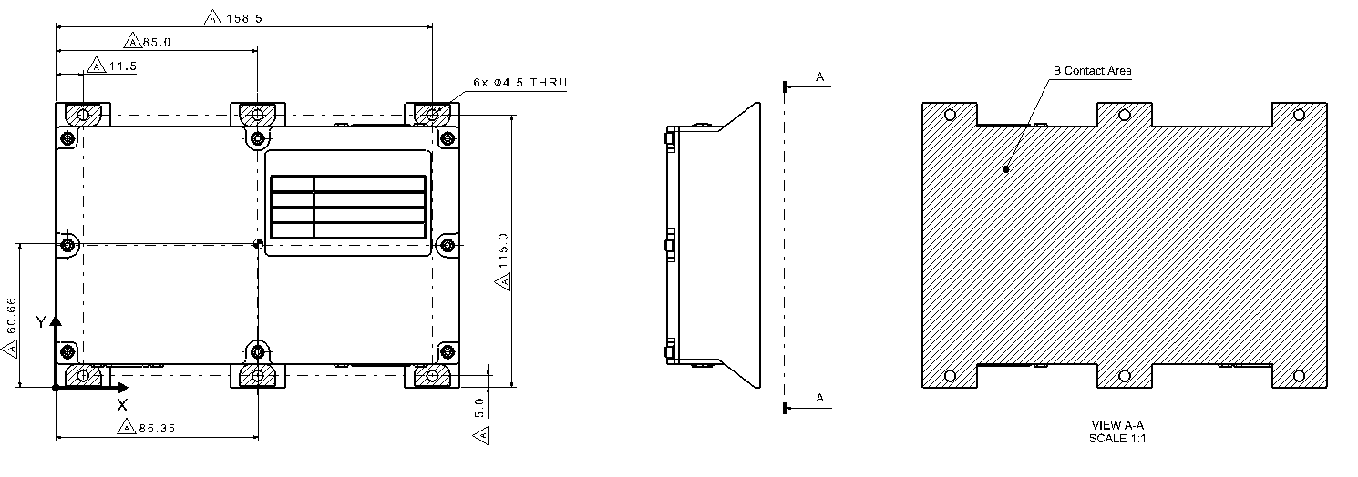
Figure 6-1 Thermal Contact Area

Thermal Characteristic
Emissivity[%] : 0%
Thermal Capacity : 540[J/K]
Thermal Dissipation : 4.768[W]

Appendix
The following document is a DMAUART interface requirement for the command and telemetry operation of payload in the KPLO. For the full document view, click the page.

